# Lab 4: Install Gitea Using Docker

## 1. Objective

The purpose of this lab is to install and configure Gitea using Docker on a Windows environment, verify that Gitea supports Git Large File Storage (LFS), and demonstrate uploading a large (1GB+) file to a repository hosted on the local Gitea instance.

## 2. Environment

- Operating System: Windows 10/11  
- Tools: Docker Desktop, PowerShell, Git, Git LFS  
- Application: Gitea (installed via Docker)  
- Browser: Microsoft Edge / Google Chrome (for accessing Gitea web interface)

## 3. Experimental Steps

Step 1: Install and Start Docker Desktop

Open PowerShell and verify Docker installation:

* docker --version

Ensure Docker Desktop is running before proceeding.

Step 2: Pull and Run Gitea Docker Container

Create a folder for Gitea data and run the Gitea container:

* mkdir C:\GiteaData  
  docker run -d --name=gitea -p 3000:3000 -p 222:22 ^  
   -v C:\GiteaData:/data gitea/gitea:latest

Then open a browser and visit http://localhost:3000 to configure Gitea.

Step 3: Verify Git and LFS Installation

Run these commands:

* git --version

Step 4: Enable LFS in Gitea

Login as administrator → Site Administration → Configuration → Enable LFS.

Step 5: Create and Push a Large File Repository

In PowerShell:

* cd C:\Users\lenovo\Documents  
  mkdir gitea-largefile-test  
  cd gitea-largefile-test  
  git init

Create a 1GB dummy file:

* fsutil file createnew largefile.zip 1073741824

Track and commit it with Git LFS:

* git lfs track "*.zip"  
  git add .gitattributes  
  git add largefile.zip  
  git commit -m "Add 1GB test file"

Add remote repo and push:

* git remote add origin http://localhost:3000/Charles/largefile-test.git  
  git branch -M main  
  git pull origin main --rebase  
  git push origin main

## Verification and Results

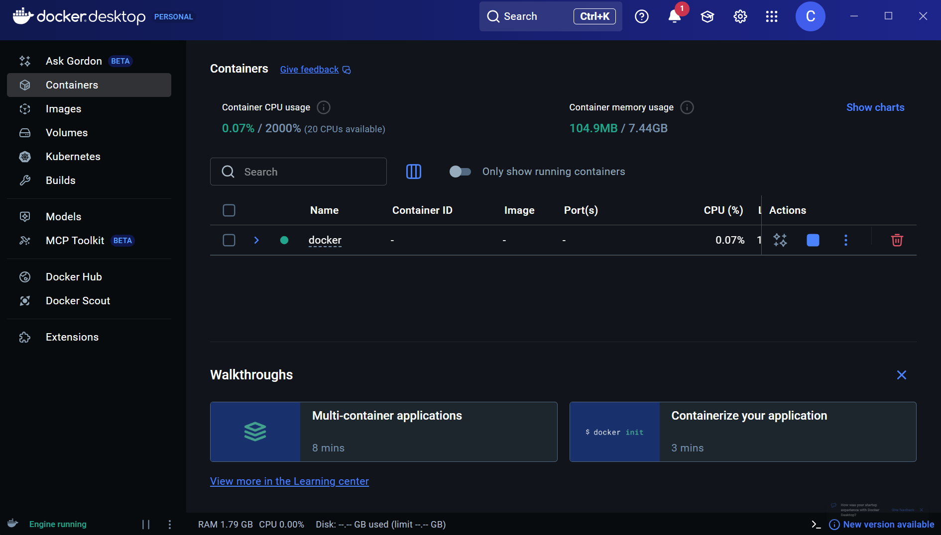

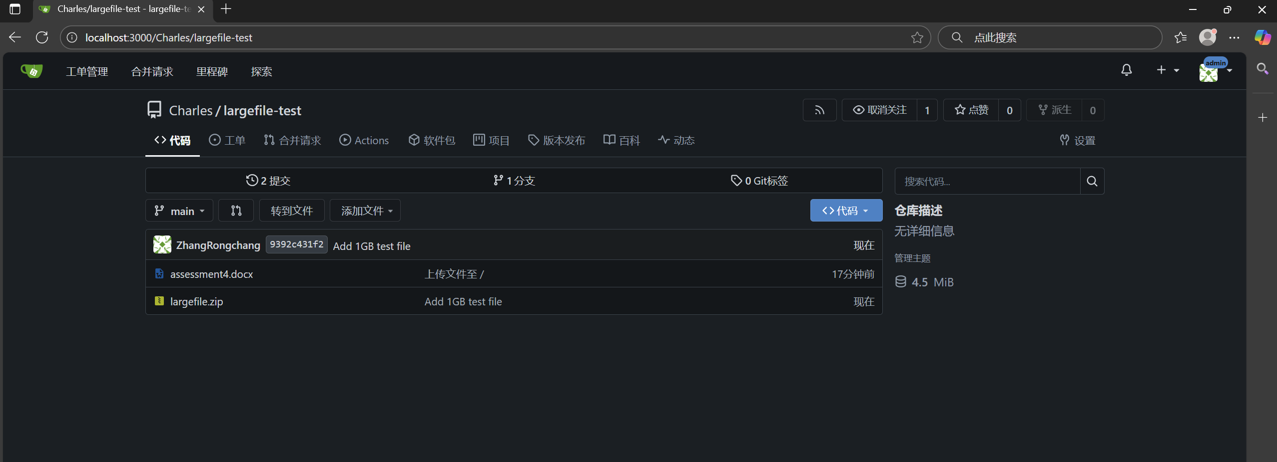



## 5. Conclusion

This lab successfully deployed Gitea via Docker and verified LFS support. A 1GB test file was uploaded to the repository, confirming Gitea’s ability to handle large binary files efficiently in a Docker environment.